**MID TEST**

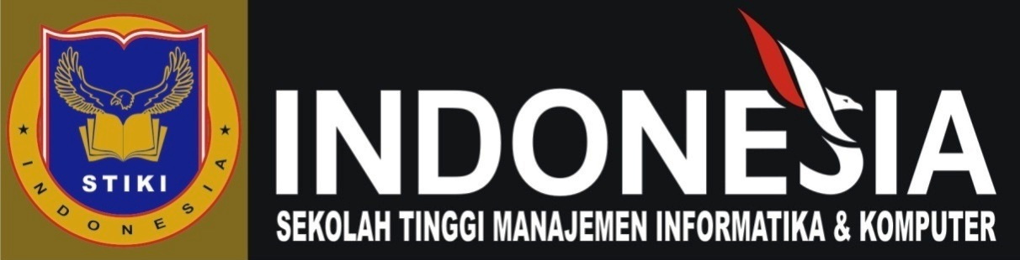

Nama : I Putu Mellana Ari Artawan

NIM : 18101028

**PROGRAM STUDI TEKNIK INFORMATIKA**

**STMIK STIKOM INDONESIA**

1. C.The woman is facing the monitor.
2. D. The drum is in front of the chair.
3. A. The man is on a pathway.
4. C. The buildings have several floors
5. C. The people are in a laboratory
6. B. The solar energy panels are turned towards the sun.
7. C. The gondolier is standing up in the gondola.
8. B. The man is standing between rocks.
9. B. You can see the shadow of the barrier on the ground.
10. A. All three children are holding on to the bar.
11. D. A conference
12. B. By bus
13. C. The woman dislikes air travel.
14. D. Make an appointment
15. C. The woman has no deadlines today
16. B. required (All materials that are required…)
17. A. finally
18. D. than
19. A. variety
20. D. favorably
21. C. each
22. B. issuing
23. A. identify
24. D. track (keep track of)
25. D. While spending
26. A. fascinated (be fascinated by)
27. B. where
28. C. hire
29. A. adapted
30. C. including ( S + V….., Ving…..)
31. B. in
32. A. open
33. C. neither not
34. B. suitably
35. A. retain
36. B. cost
37. C. survey
38. B. Its color
39. C. The A2000 to an expensive stereo system
40. A. To correct information in a previous letter